Project report
Project Name: Heritage Treasuries: An in - depth Analysis of UNESCO World Heritage sites in tableau
1.Introduction
This project, “Heritage Treasures: An In-Depth Analysis of UNESCO World Heritage Sites,” focuses on analyzing global heritage data to understand the distribution and growth of sites recognized by UNESCO. The main objective is to study how heritage sites are spread across different countries, regions, and categories such as Cultural, Natural, and Mixed. The project helps in identifying trends over the years and understanding the global importance of heritage conservation.
Using Tableau, the data is transformed into interactive visualizations and dashboards for better analysis and interpretation. These visual reports make it easy to compare countries, track inscription trends, and discover meaningful patterns. The project provides valuable insights that support awareness, research, and decision-making related to heritage preservation and cultural promotion.
1.1Project overview
Project Overview: An In-Depth Analysis of UNESCO World Heritage Sites in Tableau
This project focuses on analyzing the UNESCO World Heritage Sites dataset using Tableau to generate meaningful insights and visualizations. The goal is to understand the global distribution, trends, and key characteristics of heritage sites and present them through interactive dashboards.
1.2Objective
The main objective of the project is to:
Analyze the number of heritage sites across different countries and regions
Identify trends over the years (inscription growth)
Understand site categories such as Cultural, Natural, and Mixed
Highlight endangered (danger) heritage sites
Present insights using interactive and user-friendly Tableau dashboards

2. Project Initialization and project planning
2.1Project Initialization
Project Initialization is the first step where the project idea is defined and prepared for execution.
Project Scope
▫️Use UNESCO dataset.
▫️Clean and prepare data.
▫️Create visualizations and dashboards.
▫️Generate insights for decision making.
Key Deliverables
▫️Clean dataset
▫️Tableau worksheets
▫️Interactive dashboard
▫️Story presentation
▫️Final project report
Tools & Resources
▫️Tableau Desktop
▫️Dataset (CSV/Excel)
▫️Computer with internet access
2.2 Define problem statement
The UNESCO World Heritage Sites dataset contains valuable information about heritage locations across different countries, categories, and years. However, this data is large and complex, making it difficult to understand patterns, trends, and key insights through raw data alone.
There is a need to analyze and visualize this data to answer important questions such
🔹Which countries have the highest number of heritage sites?
🔹How have heritage site inscriptions changed over the years?
🔹What is the distribution of sites by category (Cultural, Natural, Mixed)?
🔹Which regions have more endangered or at-risk sites?
🔹What trends and patterns can help in heritage preservation and decision-making?
🔹The problem is that without proper visualization and analysis, stakeholders cannot 🔹easily interpret the data or make informed decisions.
2.3 initial project planning
Project planning and scheduling
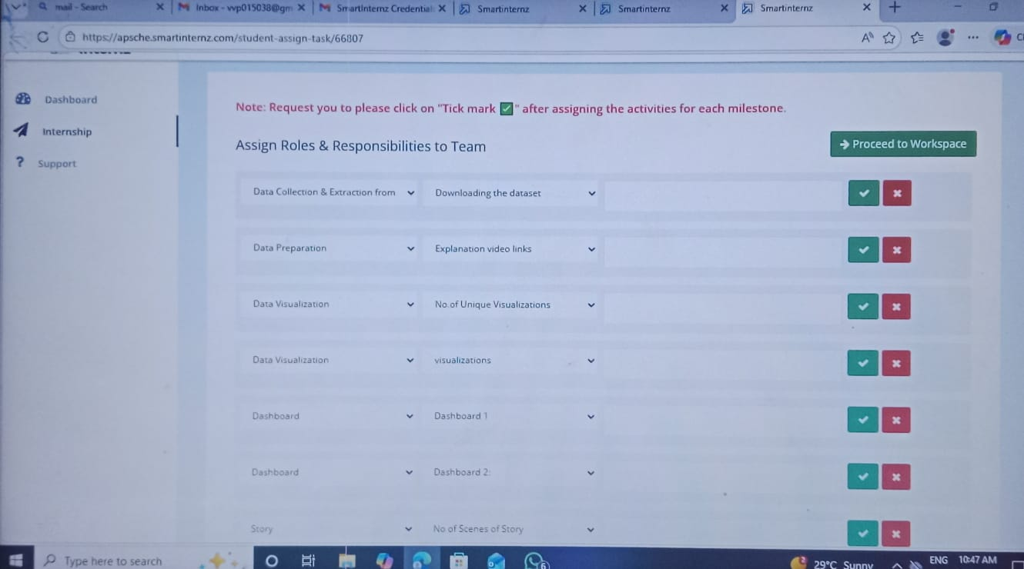

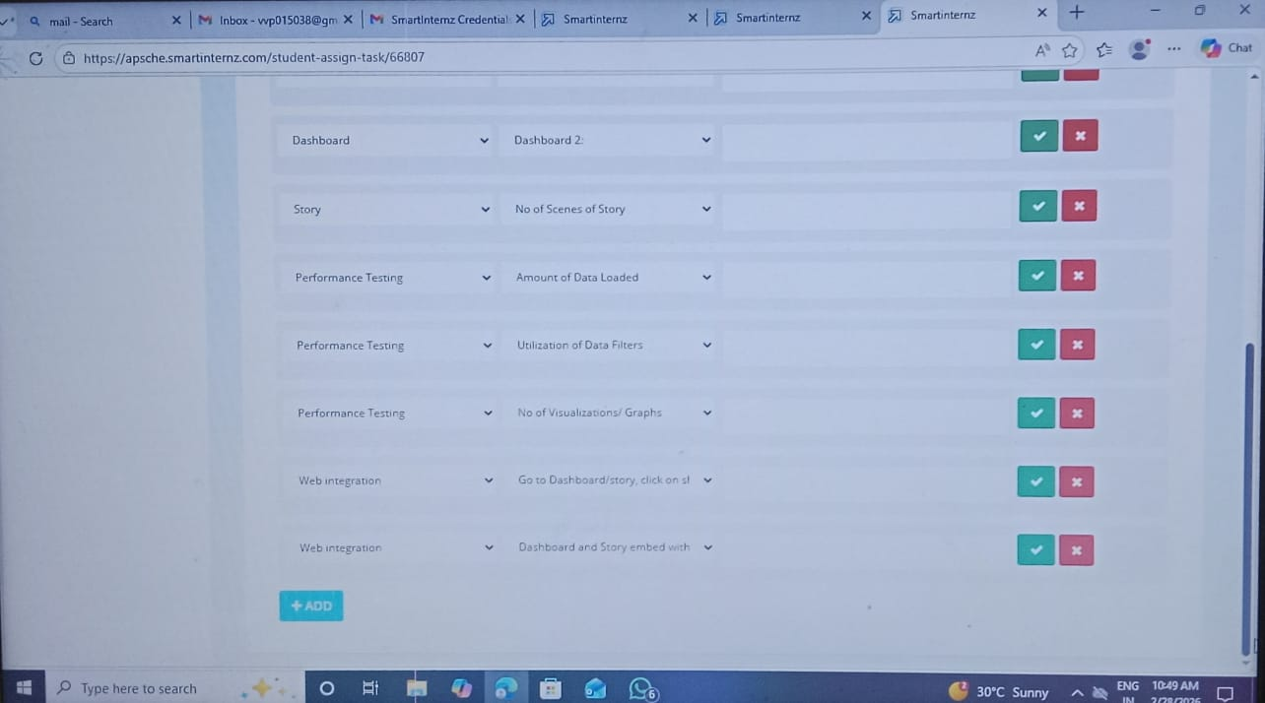
3.Data collection and processing phase
The data is collected from the official records of the UNESCO World Heritage List. It includes information about Cultural, Natural, and Mixed heritage sites across different countries and regions. Each site is evaluated and selected by experts based on its historical, cultural, or environmental significance. This dataset is important for understanding the global distribution of heritage sites, supporting conservation efforts, promoting tourism, and creating awareness about the protection of valuable cultural and natural resources.
3.1 data collection plan and raw data source identified
The data collection for this project was carried out by identifying reliable and official sources to ensure accuracy and consistency. The required data includes country name, region, heritage site name, category (Cultural, Natural, or Mixed), area in hectares, year of inscription, and geographic coordinates. The primary raw data was obtained from the UNESCO World Heritage Centre, which provides authentic and updated information about World Heritage Sites. Additional reference datasets, where necessary, were taken from platforms like Kaggle for structured formats. After downloading the data in CSV or Excel format, it was cleaned by removing missing values, correcting data types, and standardizing country and category names. The finalized dataset was then stored locally and used for analysis and visualization in Tableau.
3.2 Data quality report
The data quality check was conducted to ensure accuracy and reliability of the dataset collected from the UNESCO World Heritage Centre. The data was reviewed for missing values, duplicate records, and format errors. Incomplete and duplicate entries were removed, and data types such as area, year, and coordinates were correctly formatted. Country names and category values were standardized for consistency. After cleaning, the dataset was validated and prepared for analysis and visualization in Tableau.
3.3 Data exploration and preprocessing
The dataset from the UNESCO World Heritage Centre was explored to understand its structure and key fields such as country, category, area, and year. During preprocessing, missing and duplicate records were removed, unnecessary columns were deleted, and data types were corrected. Country names and category values were standardized. The cleaned data was then prepared for analysis and visualization in Tableau.
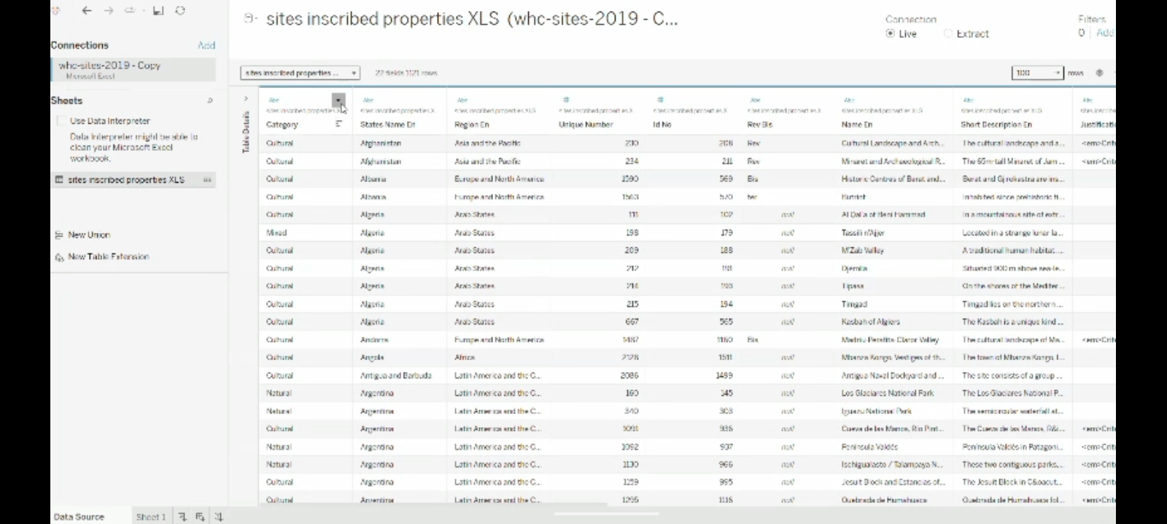

4. Data visualization
Data visualization is the graphical representation of data using charts, graphs, maps, and dashboards to make information easy to understand. It helps users quickly identify patterns, trends, comparisons, and relationships within large datasets. By presenting data visually instead of in raw numbers, decision-making becomes faster and more effective. Common visualization types include bar charts, line charts, pie charts, scatter plots, and geographic maps. Overall, data visualization improves data analysis, enhances communication, and supports better insights for businesses, researchers, and organizations.

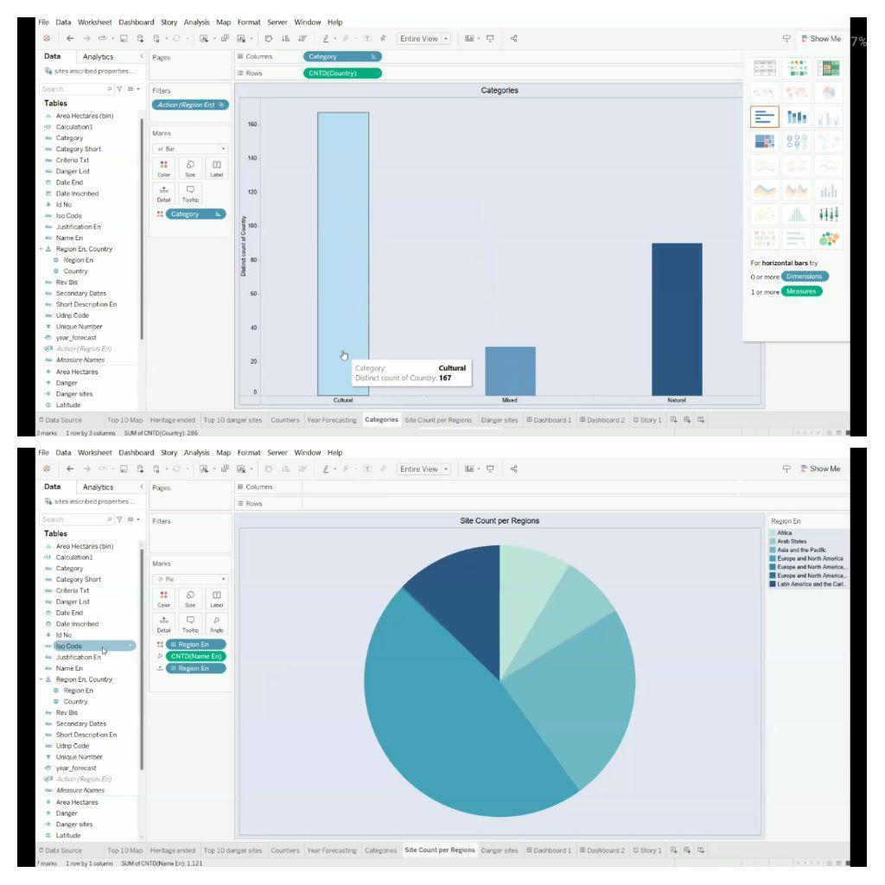

4.1 Forming Business Queries
Forming business queries is the process of creating clear and specific questions that help organizations analyze their data and make better decisions. These queries focus on understanding business performance, identifying problems, and finding opportunities for improvement. A well-formed business query connects business goals with data, such as asking about sales trends, customer behavior, profit changes, or market performance. By framing the right questions, businesses can extract meaningful insights from their data, support strategic planning, and improve overall efficiency and decision-making.
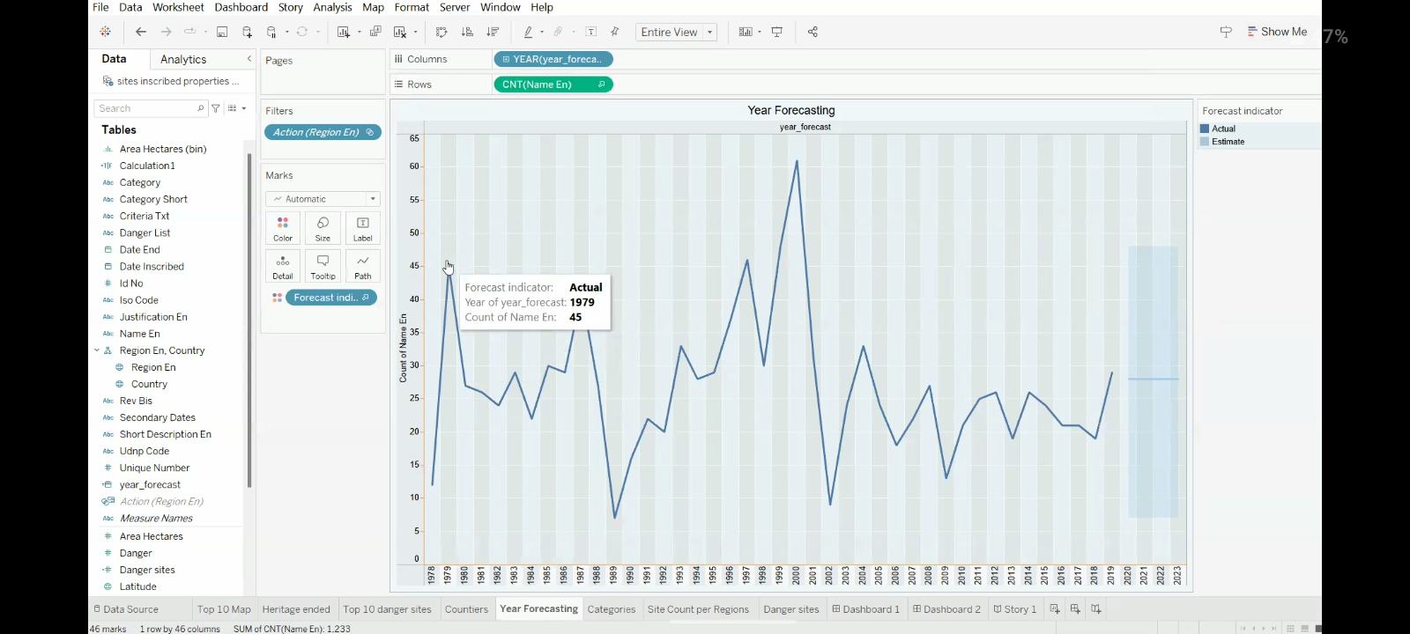
4.2 Developing visualization
Developing visualization is the process of creating charts, graphs, maps, or dashboards to represent data in a visual format so that information can be understood easily and quickly. It involves selecting the right type of visual (such as bar chart, line chart, pie chart, or map), organizing the data properly, and designing the layout with suitable colors, labels, and titles. The main goal of developing visualization is to identify patterns, trends, comparisons, and insights that may not be clear in raw data. It helps decision-makers analyze information effectively and communicate results in a simple and meaningful way.

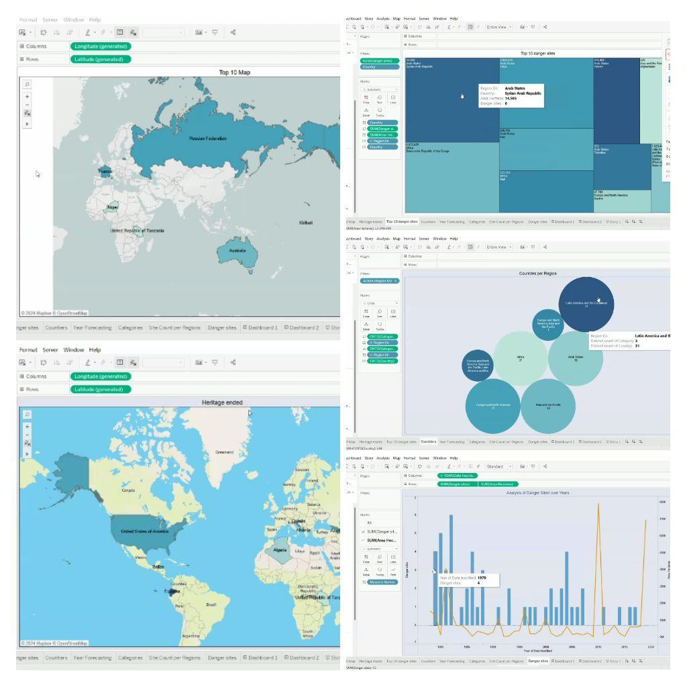
5. Dashboards
A dashboard is a visual display of important data and key performance indicators (KPIs) organized in one place for easy monitoring and analysis. It combines multiple visualizations such as charts, graphs, tables, and maps to present information clearly and quickly. Dashboards help users track performance, identify trends, compare results, and make better decisions in real time. They are widely used in business, finance, sales, and data analysis to summarize large amounts of data into a simple, interactive, and meaningful view.
5.1 dashboard design file
Creating a dashboard design file involves organizing data and planning a clear visual layout to present key information effectively. First, identify the purpose of the dashboard and the important metrics or KPIs that need to be displayed. Next, collect and clean the data to ensure accuracy and consistency. After preparing the data, choose appropriate visualizations such as bar charts, line charts, pie charts, tables, or maps based on the type of information you want to show. Then, design the dashboard layout by arranging the visuals in a logical order, adding titles, labels, filters, and color themes to make it easy to understand and visually appealing. Finally, save the dashboard design file in the required tool format (such as a workbook or project file) so it can be shared, updated, and used for analysis or presentation.
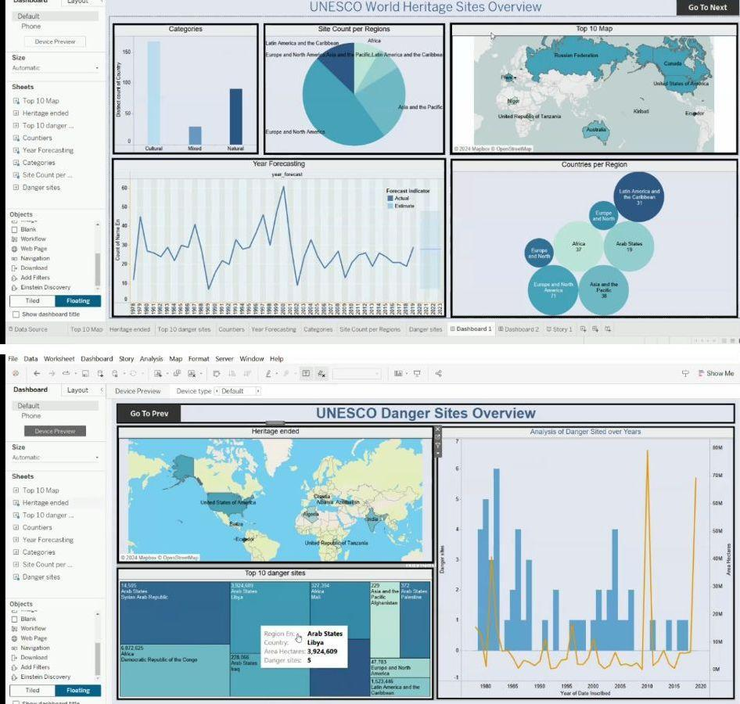

6. Report
The project story explains the complete process of turning raw data into meaningful insights. First, data was collected and cleaned to ensure accuracy and quality. Then, the data was analyzed to identify key patterns and trends. Different visualizations such as charts and maps were created to represent the information clearly. Finally, all visuals were organized into a dashboard and story format to present insights in a simple and understandable way for better decision-making.
6.1 story design file
Creating a story design file involves organizing multiple dashboards or visualizations in a sequence to explain data insights step by step. First, prepare and analyze the data, then create the required charts, sheets, and dashboards based on key findings. After that, open the Story option in your tool (such as Tableau) and add a new story. Drag the dashboards or sheets into each story point and arrange them in a logical order to show the flow of information. Add clear titles, captions, and short descriptions for each step to explain the insights. Finally, format the layout with proper spacing, colors, and navigation, and save the story design file so it can be shared or presented easily.
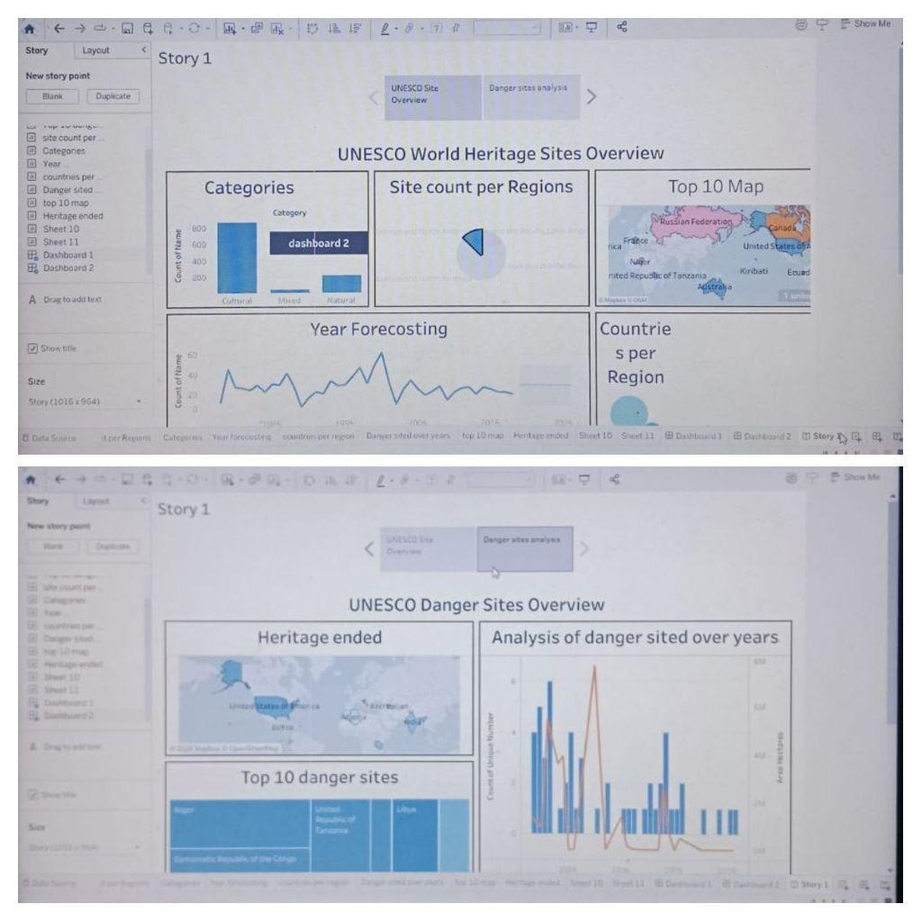
7. Performance testing
Testing performance is the process of checking how well a system, application, dashboard, or visualization works under different conditions. It involves measuring speed, response time, stability, and efficiency to ensure the system runs smoothly without errors or delays. The main goal of performance testing is to identify issues such as slow loading, data processing delays, or system crashes and improve overall performance. This helps ensure that the final product works reliably, handles large amounts of data effectively, and provides a fast and smooth experience for users.
7.1 Utilization of data filters
Project utilisation refers to how effectively project resources such as time, employees, budget, or equipment are used compared to what was planned or available. It measures the percentage of actual work completed or resources used within a project. The main purpose of project utilisation is to track efficiency, identify overuse or underuse of resources, and ensure the project is progressing as planned. High utilisation indicates resources are being used efficiently, while low utilisation shows unused capacity and the need for better planning or allocation.

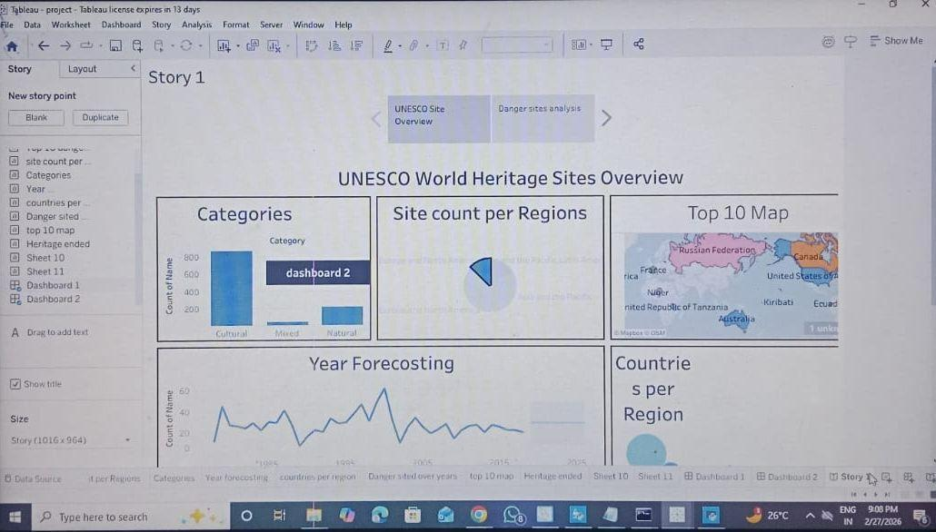

7.2 No of calculation field
Project No. of Calculation Field refers to a calculated field used in a project to count the total number of records, tasks, items, or entries related to the project. It is created to perform automatic calculations instead of manually counting the data. This field helps in measuring project size, tracking the number of activities, and analyzing project performance. For example, a calculation like COUNT(Project ID) or COUNT(Number of Records) is used to show the total number of projects or tasks. It is commonly used in dashboards and reports to provide a clear summary and support better analysis.
7.3 No of visualization
Project No. of Visualization refers to the total number of visual elements (such as charts, graphs, maps, or tables) created in a project to represent and analyze data. It shows how many visualizations are used to present different insights and information clearly. The purpose of project visualization count is to organize the analysis, cover multiple aspects of the data, and make the project more interactive and understandable. A higher number of visualizations helps in explaining data from different perspectives and improves the overall quality of the dashboard or report.
8. Project Observation
The analysis of UNESCO World Heritage Sites shows that the distribution of heritage sites is uneven across countries and regions. Some countries have a higher number of heritage sites due to rich historical, cultural, and natural resources, while others have fewer sites. The visualizations helped identify regional patterns, types of heritage (cultural, natural, mixed), and trends in site recognition over the years. It was also observed that cultural sites form the majority compared to natural and mixed categories.
8.1Project Conclusion
This project successfully transformed raw UNESCO data into meaningful insights using data visualization and dashboards. The analysis helps understand the global distribution, category-wise classification, and country-wise comparison of heritage sites. The dashboard and story make the information clear, interactive, and easy to interpret. Overall, the project supports better understanding, decision-making, and awareness for the preservation and management of world heritage sites.
9 . Future scope
The future scope of this project is to enhance the analysis by adding more recent and updated UNESCO World Heritage data to track changes over time. Advanced visualizations and interactive dashboards can be developed to provide deeper insights such as year-wise growth, risk status analysis, and region-wise comparisons. The project can also be integrated with web platforms for real-time access and sharing. In addition, predictive analysis and trend forecasting can be implemented to identify future heritage site patterns. Further improvements like mobile-friendly dashboards, automated data updates, and detailed performance monitoring will make the project more useful, scalable, and effective for research and decision-making.
A project appendix is a section added at the end of a project report that contains supporting information which is useful but too detailed to include in the main content. It helps readers understand the work better by providing extra materials such as raw data, charts, questionnaires, screenshots, calculations, or technical details. The appendix keeps the main report clear and concise while still giving complete evidence and reference for the project.
10.1 source code
Tableau public in published my dashboards and story link https://public.tableau.com/app/profile/savra.liyani/viz/Tableaupublic_17721336072960/Story1?publish=yes
Tableau public in published my dashboards https://public.tableau.com/app/profile/savra.liyani/viz/Tableaupublic_17721336072960/Dashboard1
Browse in published my templets file:///C:/Users/DELL/Desktop/flask_project/tamplets/index.html
10.2Github & project demo link

